Solid Pods

* Like secure personal web servers for you data
* Any kind of information can be stored in a Solid Pod
  + A users sleep, steps, name, weight, gender, day of last period, medication, etc
* The user controls the access to the data in their Pod
* To store and access data in your Pod, application use standard, open, and interoperable data formats and protocols

Data

* Solid supports storing Linked Data
* Different applications can work with the same data

Solid Applications

* Store and access data in Pods using the Solid Protocol
* Different applications can access the same data in a Solid ecosystem
* A user has to grant access to the application to read your information
* A Solid app is an application that reads or writes data from one or more storage

Data Structure

* Misconception that it is a set of documents, but in reality is a hybrid graph
* Allows for innovation and creativity
* How to make data work for all other apps?
* Single hierarchical collection of documents
* Linked data principles 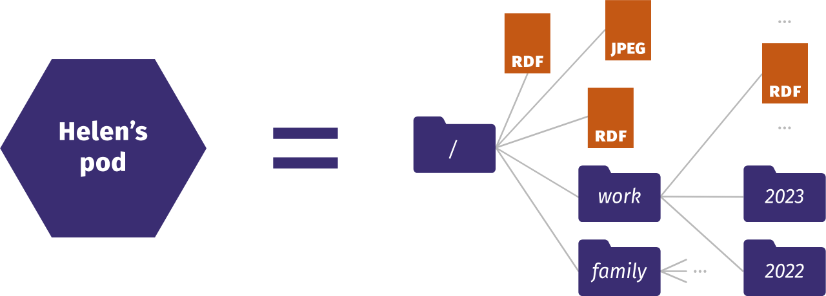
  + 1. Use URIs as names for things.
  + 2. Use HTTP URIs, so that people can look up those names.
  + 3. When someone looks up a URI, provide useful information, using the standards (RDF, SPARQL).
  + 4. Include links to other URIs, so that they can discover more things.
* Users have a WebID

Hormonal Cycle (Female)

* On average, lasts 28 days
* However, cycles can be from 21-35 days and be normal
* There are four phases
* The menses phase
  + Begins the first day of your period
  + Lasts from 3-7 days
  + triggered by a drop in progesterone production
  + triggers your period to start which is the shedding of your uterine lining
  + Once your lining has been shed, estrogen levels begin to rise again as your body starts the whole cycle all over again.
  + may experience cramping and other symptoms
  + Self-care during this phase is all about taking it easy
  + important to make sure you aren’t overwhelming yourself
  + minimize your exposure to stress
* The follicular phase
  + Begins the first day of your period and ends around day 14 of your cycle in an average 28 day cycle
  + Overlaps with menses phase
  + Estrogen levels rise which triggers your uterine lining to thicken in preparation for the possibility to host a fertilized egg
  + likely to feel energetic both physically and emotionally
  + Be active during this time, visit friends, hit the gym, go for a walk
  + Engage in activities that rejuvenate you and also require you to be active
* Ovulation
  + lasts about three to four days
  + hormone levels change which triggers a follicle, which contains an egg, to burst and travel through the fallopian tube into the uterus
  + continue to feel energetic and will be stable mood-wise. In fact, during this phase, you will likely feel the most energetic out of all of the stages in your cycle.
  + Practicing self-care will probably feel the easiest in this phase because you have the energy to invest in a dream self-care routine.
  + Focus on getting those workouts in, spending time with friends and family, and engaging in your favorite leisure activities and hobbies.
* The luteal phase
  + From day 15 to day 28
  + last approximately ten to fourteen days
  + hormone progesterone rises which signals to the body to keep the uterine lining intact
  + if the egg has not been fertilized, progesterone production drops until it halts which will trigger the start of your period.
  + energy levels will decline and you may start to experience premenstrual symptoms such as bloating, irritability, and certain cravings.
  + Since your energy levels are starting to decline, snuggling up on the couch with a good book or taking a relaxing bath begins to sound much more appealing than going out for a brisk walk or going through an intense workout at the gym.
  + Try going to the gym for a shorter amount of time and doing a less intense workout.

To track your period:

* Mark the first day of your period on a calendar with an X. This is day one.
* Continue to mark each day you’re bleeding with an X. Stop marking when your bleeding stops.
* When bleeding starts again, mark it with an X. This is day one again.
* You can then count the number of days between each first X to get the length of your cycle. Count the number of X’s to see how many days bleeding lasts.

There are also apps that do all of this for you that you can download on your phone or tablet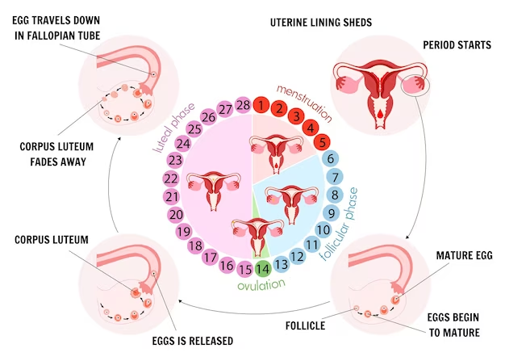

Hormonal Cycle (Male)

* Men experience a full testosterone cycle every 24 hours
* Testosterone in men reaches its peak in the early morning, decreasing steadily after 9am throughout the day
* Morning
  + testosterone peak
  + men are more talkative, energetic, focused, and aggressive
  + more competitive, confident, and impulsive
  + quicker to anger and more inclined to turn down requests for favors
  + Take on DIY tasks
  + Tackle a project alone
  + Figure out the best route to somewhere
  + Enjoy sex
  + Not hear bad news or tackle tricky subject
* Afternoon
  + men are still upbeat, driven and focused, but not angered so easily
  + better time to work as part of a team
  + Have meetings with customer or clients
  + Have a team meeting or brainstorming session
  + Go for a date
* Night
  + men are much more low-key, passive and agreeable.
  + Do relaxing activities such as watching a film or reading
  + Enjoy some affectionate cuddling